Assignment 1

USE movie_booking_system;

1.select name as movie_Name from movie

where length_min>100;

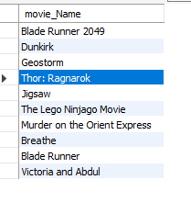

2. select name from movie order by name asc;

select name from movie order by name desc;



3.select id,length_min from movie where length_min between 100 and 150;

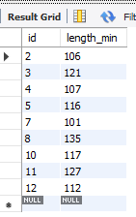

4. select length_min from movie where length_min in(106,121,116);

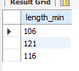

5. select length_min from movie where length_min not in(106,121,116);

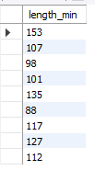

select name from movie where name like 'B%';

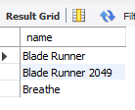

select name from movie where name like '%s';

select name from movie where name like 'j%w';

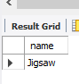

alter table movie rename column name to Movie_Name;

select * from movie inner join customers on movie.id=customers.id;

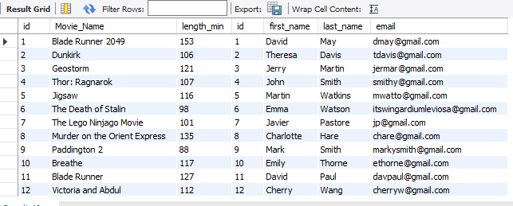 select * from movie inner join customers on movie.id=customers.id;

select movie_name,customers.id from movie inner join customers on movie.id=customers.id;

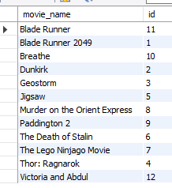

select * from movie left join customers on movie.id=customers.id;

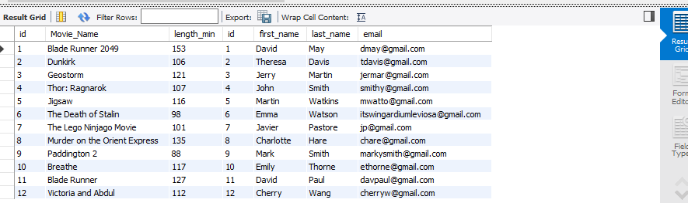

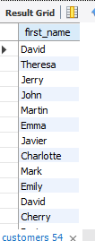select first_name from customers where first_name is not null;

select first_name,last_name from customers where first_name is null;

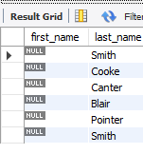

select * from customers where id=1;

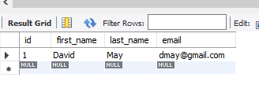

select *from customers inner join rooms on customers.id=rooms.id;

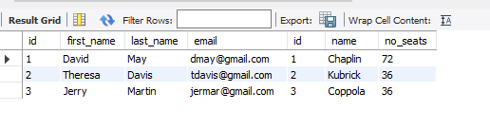

select *from customers left join rooms on customers.id=rooms.id;

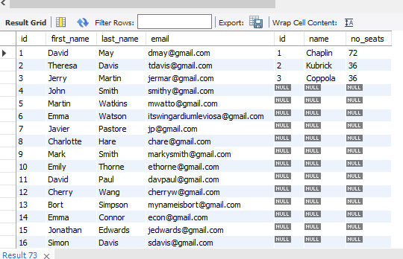

select * from movie right join rooms on movie.id=rooms.id;

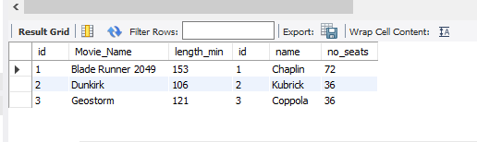

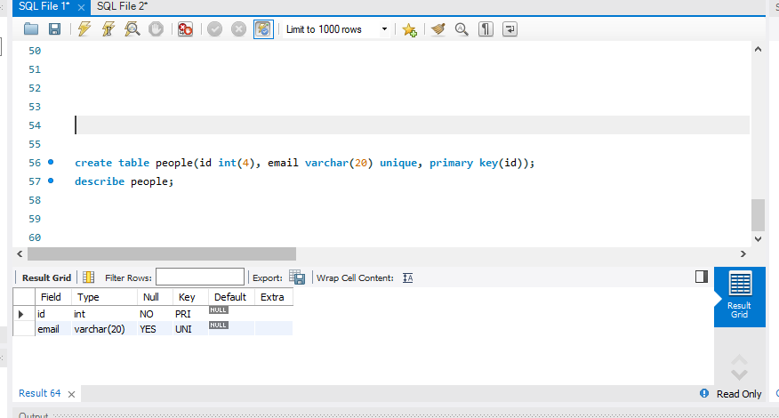

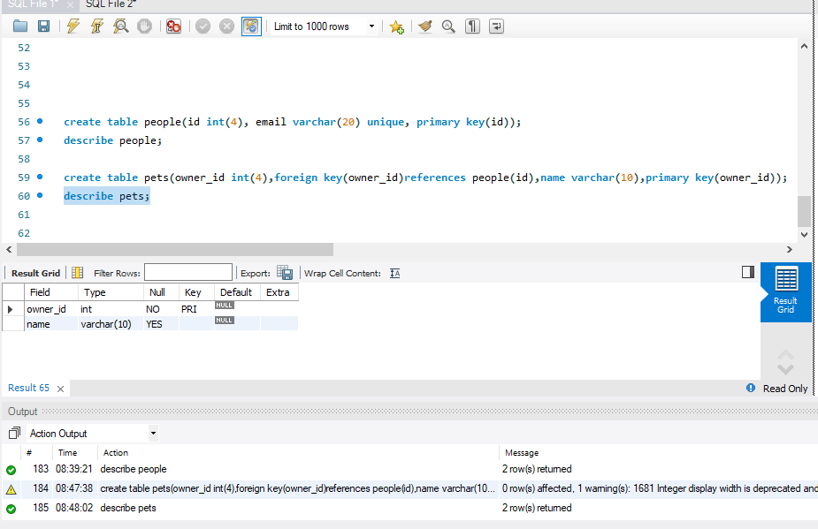

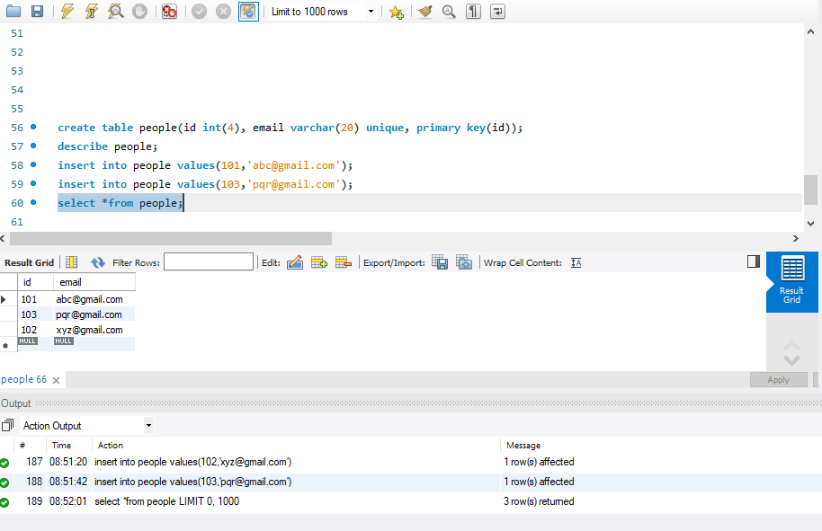

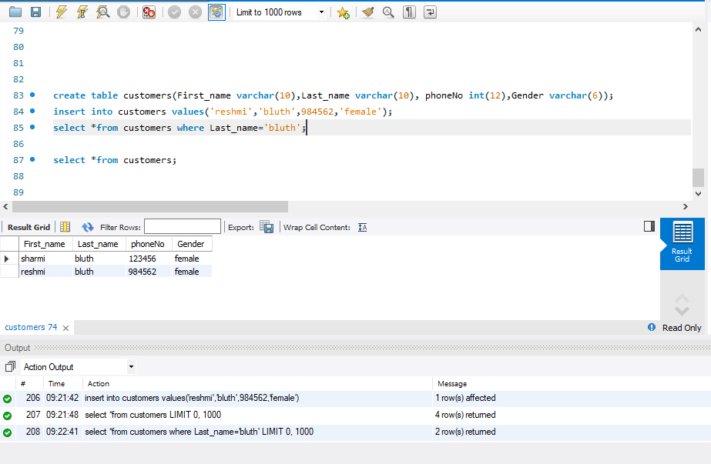

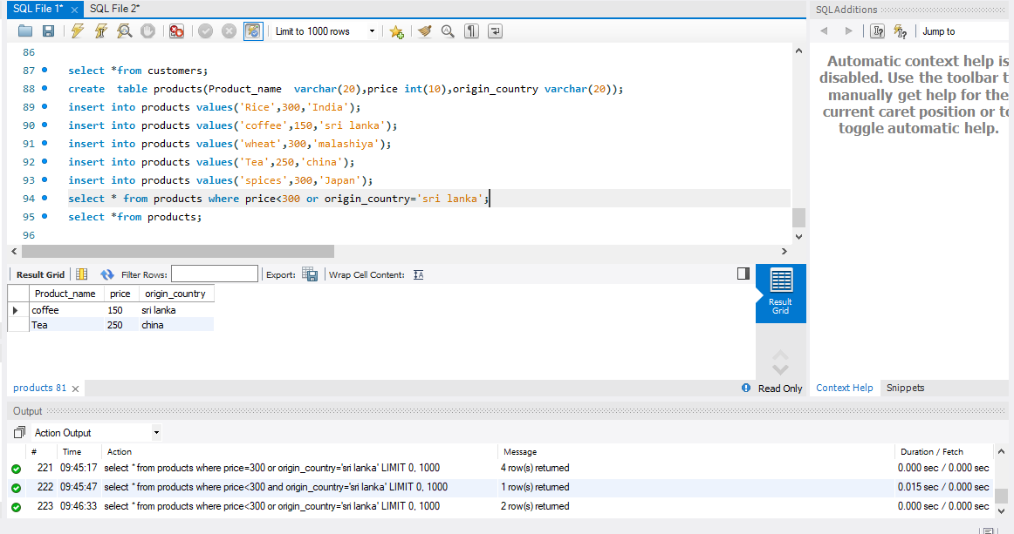

**Inner Joint on movie and Screenings:**

**select * from movie inner join screenings on movie.id=screenings.film_id;**

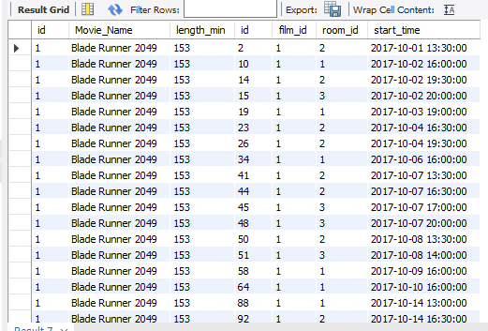

**select * from movie left join rooms on movie.id=rooms.id;**

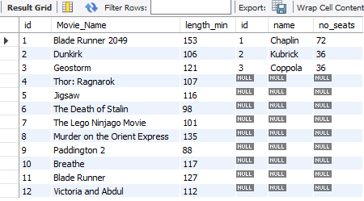

**select Movie_Name,rooms.name,rooms.no_seats from movie left join rooms on movie.id=rooms.id;**

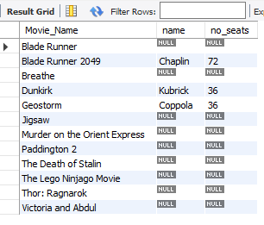

**select * from rooms inner join screenings on rooms.id=screenings.id;**

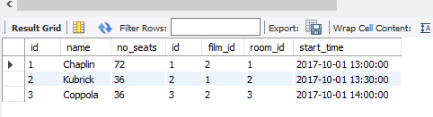

delete from movies;

drop table movies;